Ben Evans
CS 255 Project 2: System Design Document
4/19/2026

UML Diagrams

UML Use Case Diagram
The use case diagram below identifies the five actors in the DriverPass system: Customer, Secretary, Owner, IT Officer, and the DMV as an external system, along with all fifteen use cases covering account management, appointment scheduling, online practice testing, package management, administrative functions, and DMV integration.

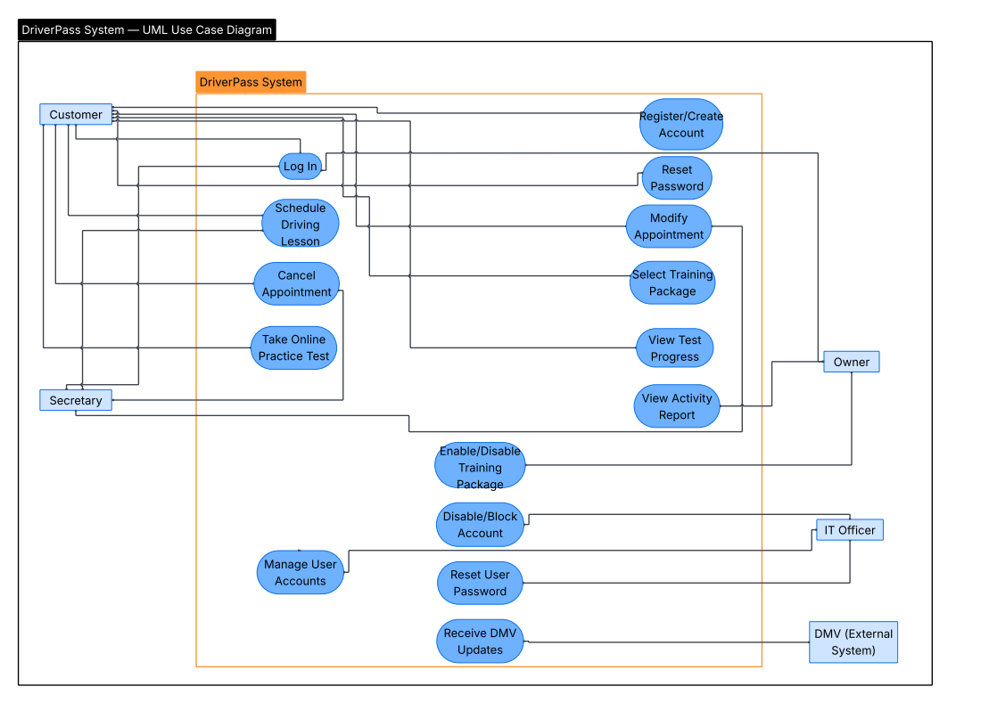

UML Activity Diagrams
Two activity diagrams are included below. The first models the Schedule Driving Lesson use case. The second models the Take Online Practice Test use case.
This diagram begins when a customer logs into their account. The system checks whether they have an active package. If not, they are prompted to select one. Once confirmed, the customer selects the preferred date and time. The system checks driver and car availability. If unavailable, the customer selects a new time. Once a slot is available, the reservation is confirmed, a record is created tracking the customer, driver, car, and time, and confirmation is sent to the customer.
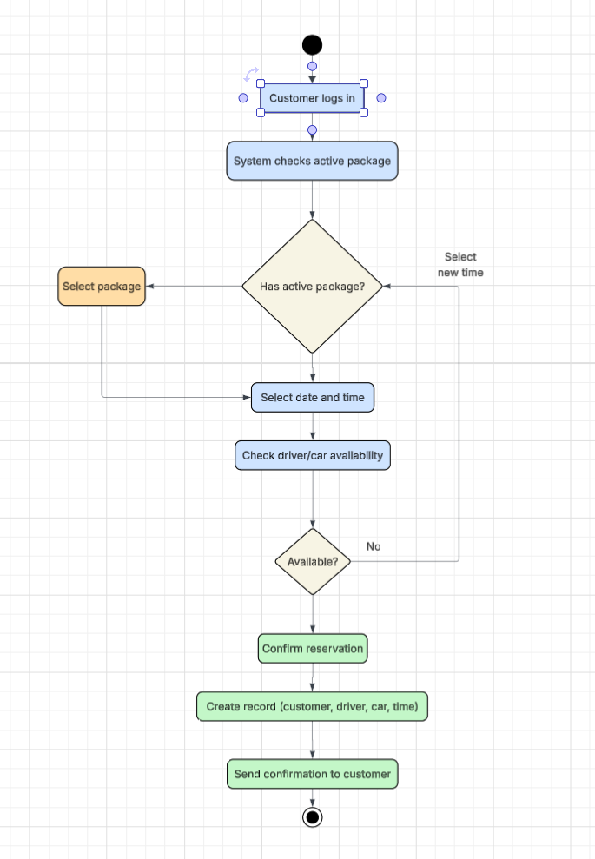
This diagram begins when a customer logs in and navigates to the online practice test section. The system verifies that their package includes online access. The customer selects a test and begins. Upon completion, the system calculates and displays the score, records the result with a status of passed or failed, and updates the customer's test progress dashboard.

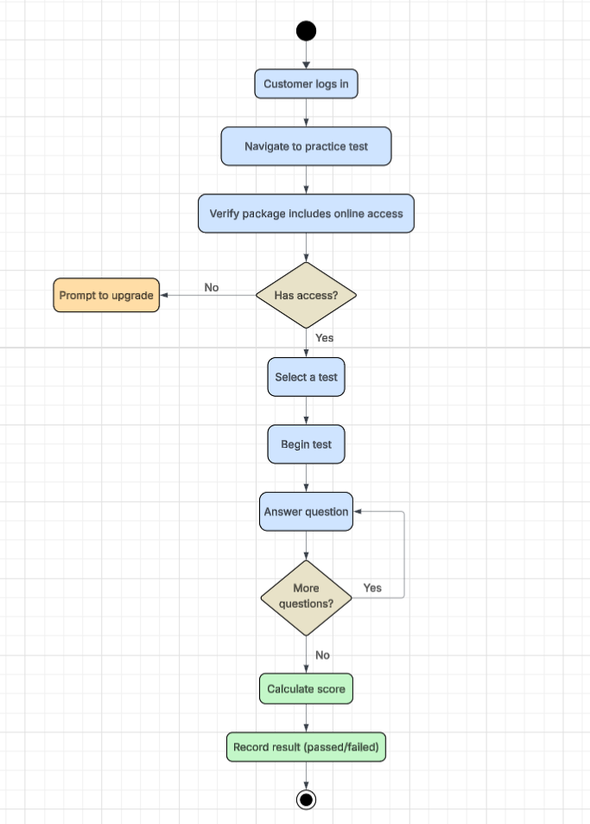

UML Sequence Diagram
The sequence diagram below models the Schedule Driving Lesson use case, showing the messages exchanged between the Customer, the DriverPass System, and the Database. It captures the full interaction from login through reservation confirmation, including availability checks and record creation.
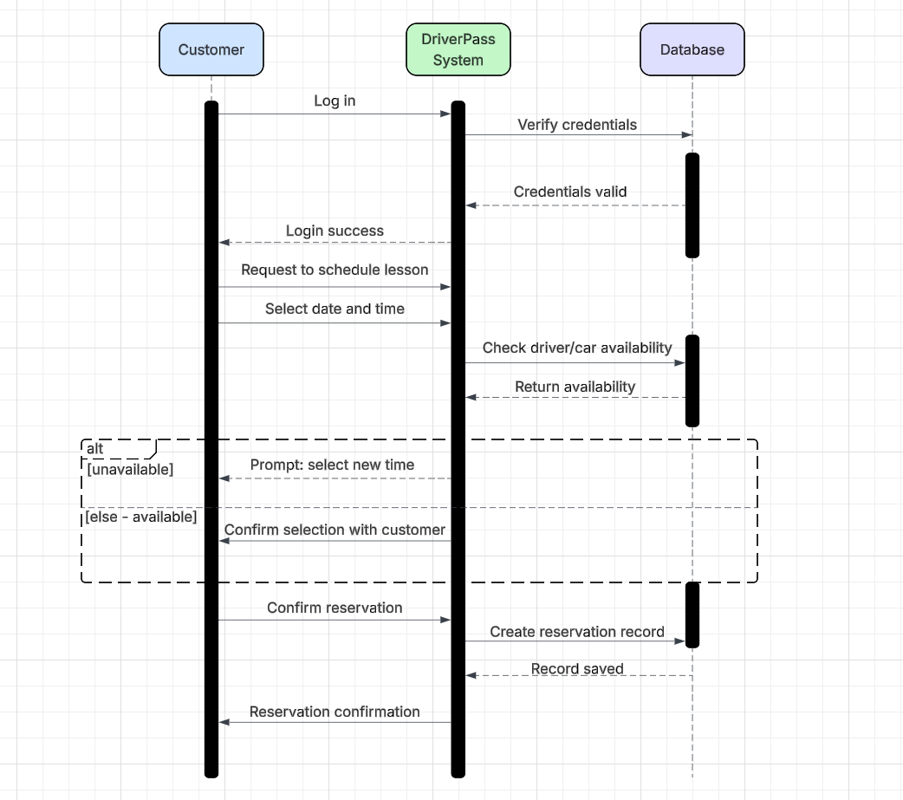

UML Class Diagram
The class diagram below shows the key classes in the DriverPass system, their attributes, and the relationships between them. The primary classes are User (parent class), Customer, Secretary, Owner, ITOfficer, TrainingPackage, Reservation, Driver, Car, OnlineTest, and BankAPIConnection.

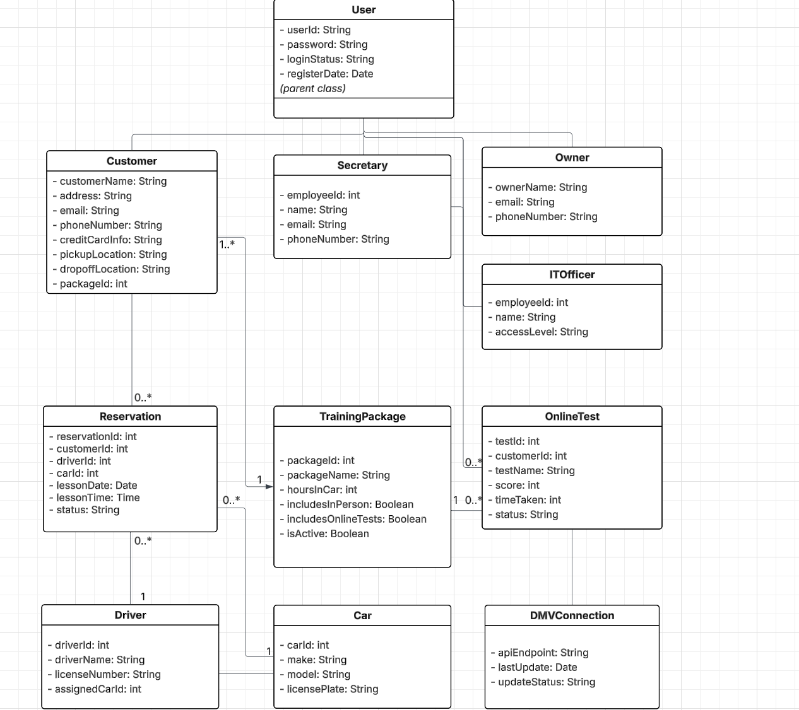

Technical Requirements

Hardware Requirements
- Web-accessible devices: The system must be accessible from standard desktop computers, laptops, tablets, and smartphones. No specialized hardware is required for end users.
- Cloud-based servers: The system shall be hosted on cloud infrastructure (such as AWS, Azure, or Google Cloud) to eliminate the need for DriverPass to maintain physical servers.
- Sufficient server capacity to handle concurrent user sessions, database queries, and DMV data connections without exceeding the 10-second response time requirement.

Software Requirements
- Web application framework: The system shall be built using a modern web application framework compatible with standard browsers on both desktop and mobile operating systems.
- Database management system: A relational database (such as MySQL or PostgreSQL) is required to store user accounts, reservations, package information, test results, driver assignments, and activity logs.
- Authentication system: Secure login with role-based access control must be implemented to distinguish between Customer, Secretary, Owner, and IT Officer user types.
- Automated password reset: Software support for email-based password reset functionality is required for self-service account recovery.
- DMV integration: An API connection to the DMV system must be established to receive automatic content updates for practice tests and driving rules.
- Report generation: The system must include software capable of generating and exporting activity reports in a format compatible with Microsoft Excel.

Infrastructure Requirements
- Cloud hosting: The system must be hosted on a cloud platform that provides managed security, automated backups, and reliable uptime of at least 99.9% availability.
- HTTPS encryption: All data transmitted between the user's browser and the server must be encrypted using HTTPS/TLS to protect sensitive information.
- Internet connectivity: An active internet connection is required for all data-modifying operations. Read-only data such as downloaded reports may be accessed offline.
- DMV network connection: A stable internet connection between the DriverPass system and the DMV's API is required to receive timely content updates.

Security Requirements
- Role-based access control: Each user role must have distinct permissions enforced at the application level, preventing unauthorized access to functionality or data.
- Brute-force protection: The system must implement account lockout after a defined number of consecutive failed login attempts.
- Data encryption: All sensitive data including credit card information and personal details must be encrypted at rest and in transit.
- Audit logging: All reservation activity must be logged with user identity and timestamp to support activity reporting and accountability.
- IT Officer account management: The IT Officer must be able to reset any user's password and disable or block any account to respond to security incidents or personnel changes.

